
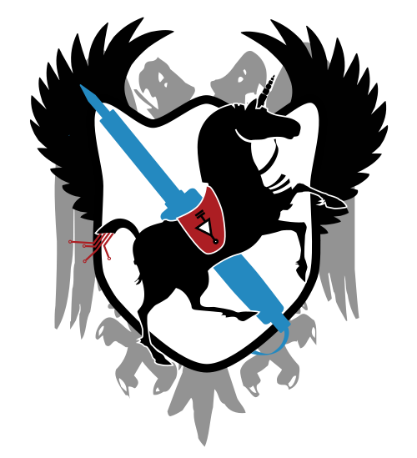
True Scotsman

Letter of Sanction

At the behest of the free folk of the Scotland, permission has hereby been granted for:

To don a Kilt and act in the position of honorary Jock.
While acting under this sanction, there are a number of responsibilities which must be adhered to:
- Must be in possession of a receptacle containing whisky at all times.
- A profanity ratio of at least 1:20 must be adhered to.
- Money must only leave the sporran begrudgingly.
- Must always be responsible for payment of the last round.
- Can never be present at the last round.
- Enjoyment can only be indulged through Schadenfreude
- You can never accept corrections in pronounciation.
- You must accept Buckfast as your lord and saviour.
- There is no such thing as a True Scotsman.
- You are a True Scotsman.
Produced by the Scottish Consulate

